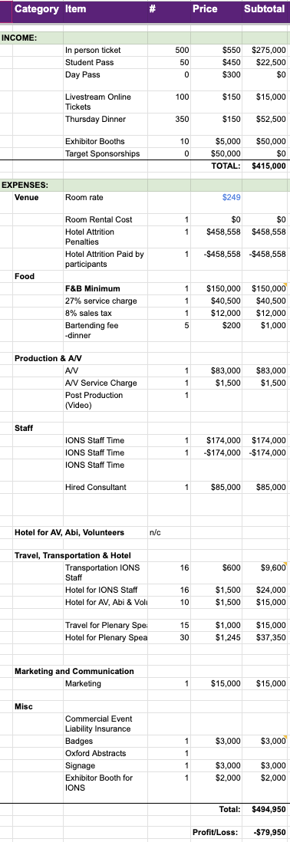
Consciousness Science 2026 budget

This is the original E&E budget.
Optional expenses
- Budget includes $41,000 optional IONS expense (marketing, staff travel)
- Budget includes contractor for 1 year ($85k) while only half a year is needed ($42.5k)
- Budget includes ~$10k for volunteer hotel (while volunteers will likely be local)

Additional potential revenues
- Budget above does not include $200k sponsorship
- Budget only accounts for 500 participants while 700 are expected (an additional $165k revenue).

The budget above is for a conservative 500 participants.
- A worst case scenario with 300 participants results in a $37k surplus.
- A best case scenario with 800 participants results in a $312k surplus.
(Previous conferences have had about 700 participants.)

Additional IONS specific optional expenses
- The conference could be fully managed by contractor Abi Behar Montefiore, as she has in the past. This is included in the budget and priced at $45k for six months, starting July 1st.
- Optional IONS staff full production is estimated to requite an additional $209k.
